P. cunningtonii vs P. elpatiewskyi
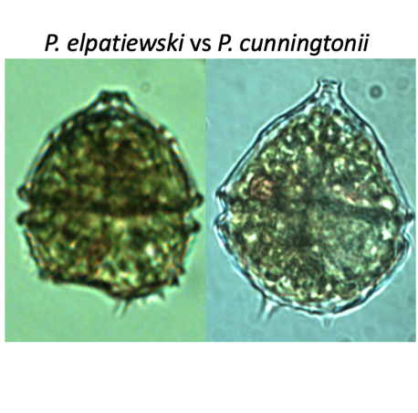
Morphological features: These two species are not so easy to tell apart: they are of the same size and occur in the water at the same time. Examining their thecal plate structure allows distinction between them: the plates differ in number and arrangement, especially when observed from above (Plate 1). However, without an SEM the plates are usually seen only on empty theca. To identify the living cells under the light microscope we examine (Plates 1, 2, 3):
(1) cell shape – P. elpatiewskyi is angular whereas P. cunningtonii is smooth and rounded, especially its quinquecuspidata forma;
(2) spines on hypotheca – P. cunningtonii has 1-4 spines, more or less of the same size and evenly spaced. P. elpatiewskyi has 2-3 main spines and to the side of one of them a “brush” of smaller spines.
(3) hypotheca base - in P. elpatiewskyi it is flat to concave whereas that of P. cunningtonii is rounded.
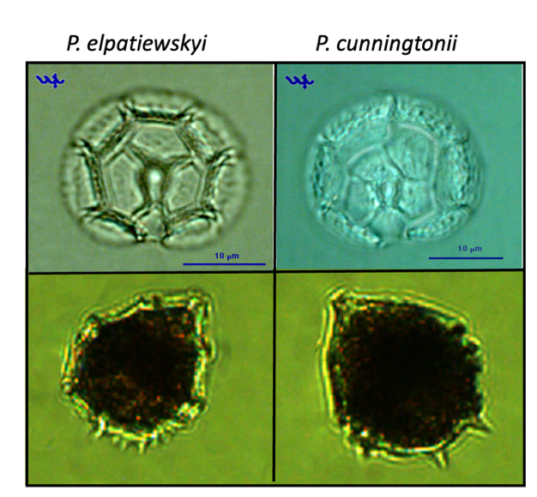
Plate 1. Distinguishing between Parvodinium elpatiewskyi (left) and P. cunningtonii (right). Top: epitheca of both species showing the different number and arrangement of the thecal plates of the epitheca. Bottom: P. elpatiewskyi (left): angular shape, flat bottom, a “brush” of spines on one side of hypotheca; P. Cunningtonii (right): rounded shape, rounded base of the hypotheca, two distinct and separated spines.
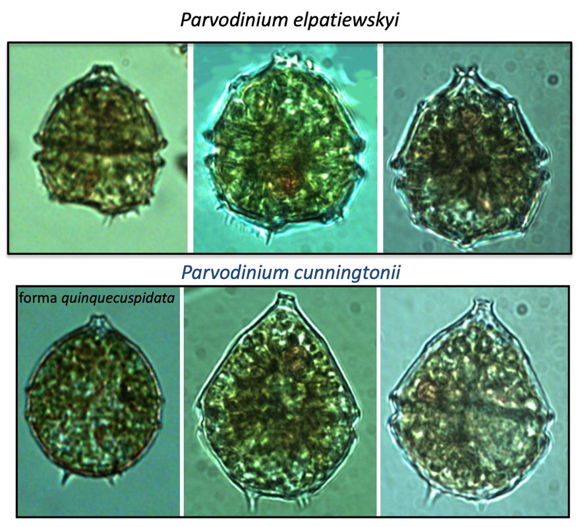
Plate 2. Distinguishing between Parvodinium elpatiewskyi and P. cunningtonii: light microscopy.
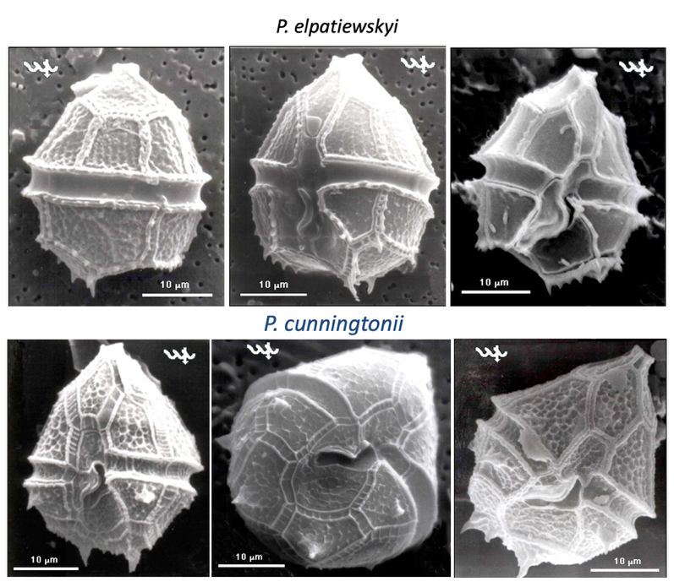
Plate 3. Distinguishing between Parvodinium elpatiewskyi and P. cunningtonii: SEM microscopy. Note punctae along plate margins in P. elpatiewskyi that are absent in P. cunningtonii. Also note concave shape of plates only in P. elpatiewskyi.

